

Thank you for ordering a made to measure suit from Hybrid Racing ! To make sure we get it right for you please double check your measurements and make sure that they are taken in centimetres. You should wear a t-shirt and shorts or tight fitting clothing. We allow space for back protectors so please do not add anything. If you are not sure about anything, please contact us. You can print this form and write your measurements below or you can email them to hybridracingca@hotmail.com

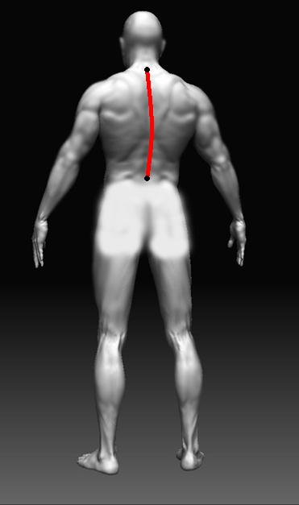
1 - Back Length
Measure from the bone at the
top of your spine (base of your neck)
to your waist belt line. This point should be
in line with the top of you hip bone.

___

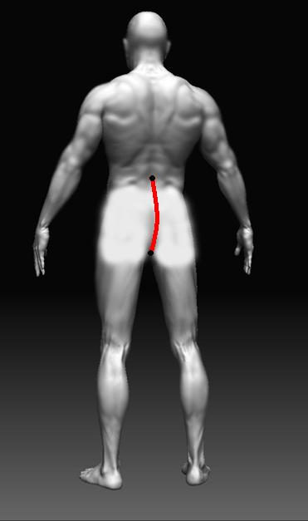

2 - Waist to Crotch Back
Measure from the same point as #1 (your waist
belt line) to the centre point of the inside crotch
___

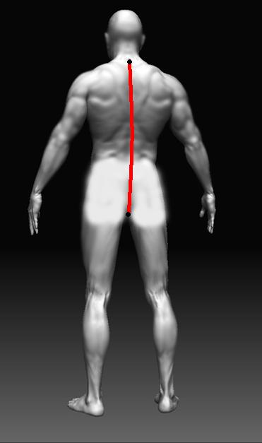
3 - Neck to Crotch back
Measure from the bone on your spine at
the base of your neck to the centre point
of the inside crotch (same point as #2)
Measurements 1 + 2 should add up to this
measurement, please do not proceed until
they do

___
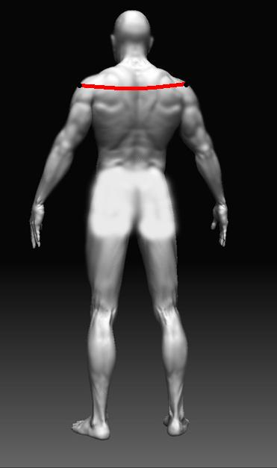

4 - Cross Shoulders
Measure from the centre tip of one shoulder, across
the top of your back to the centre of the tip of your
other shoulder

_____
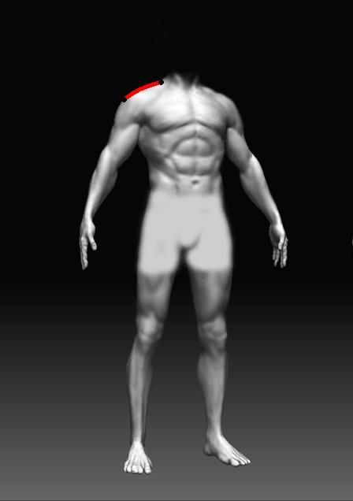

5 - Shoulder Slope
Measure from the base of one shoulder slope
to the tip of your same shoulder

_____

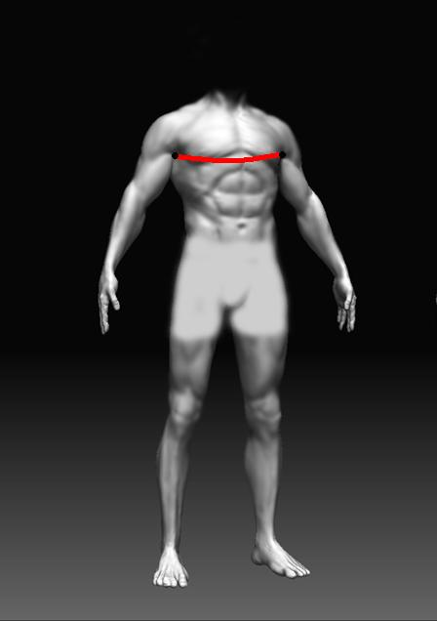
6 - Chest
Measure all the way around your chest,
across your back, underneath your armpits
at the widest point. Take the measurement when
breathing out.

_____

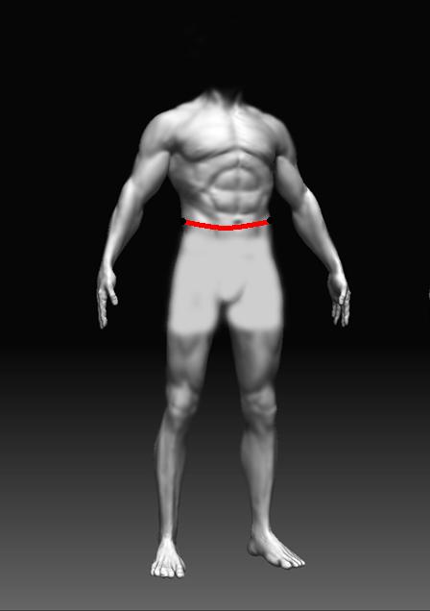
7 - Waist
Measure all the way around your waist at the
widest point. Take the measurement while breathing
out

_____

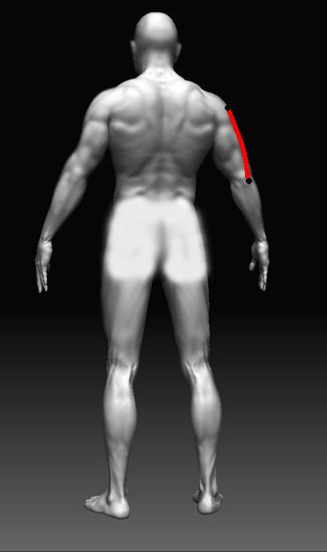
8 - Shoulder to Elbow
Measure from the tip of your shoulder to the
tip of your elbow on one arm. Keep your arm bent
at 90 degrees.

____

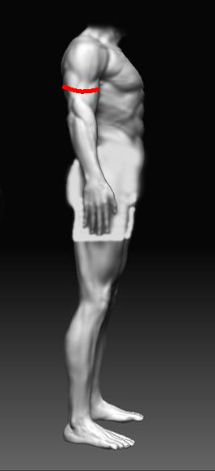
9 - Biceps
Measure all the way around the top of
your arm or your bicep when tensed.

_____

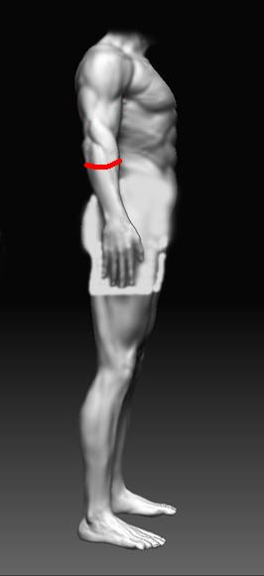

10 - Forearms
Measure all the way around the top
of your forearm when tensed.

_____

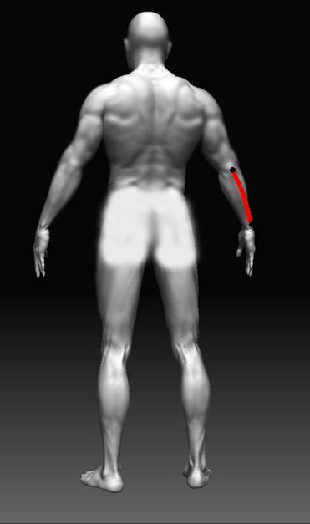

11 - Wrist to Elbow
Measure from the tip of your elbow to the
Ball bone on your wrist (most prominent bone
just before it meets your hand) keep your arm bent
At 90 degrees

____

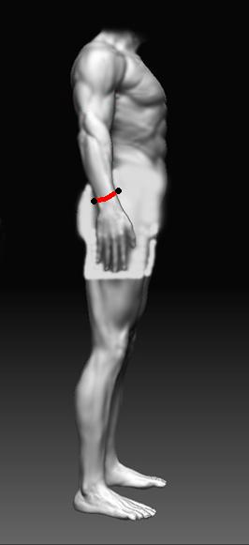
12 - Wrist
Measure all the way around your wrist

_____

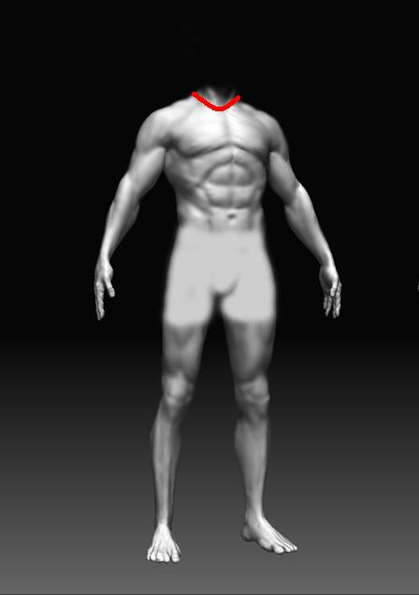
13 - Collar
Measure loosely all the way around the
bottom of your neck as low as you can go.

_____

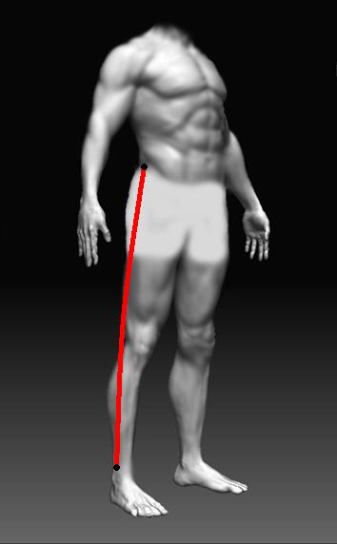
14 - Outside Leg
Measure from the top of your hip bone
(usually at the top of your waist belt line) to your
ankle, just above the ball ankle bone

___

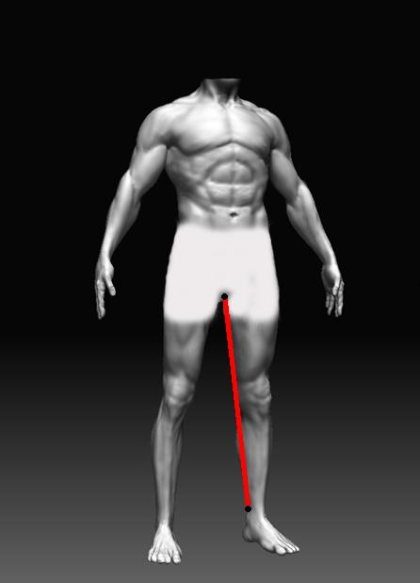
15 - Inside Leg
Measure from the inside of your groin as high
as you can to the same point on your ankle
as your outside leg but on the other side,

_____

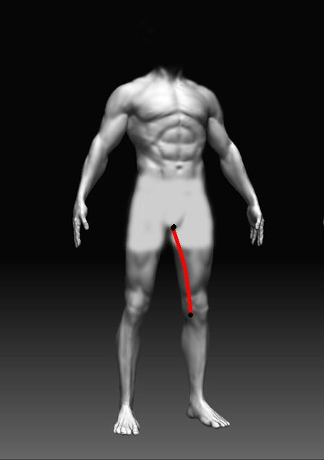
16 - Crotch to Knee
Measure from the inside of your crotch
to the centre of your kneecap, keep your
knee slightly bent

_____
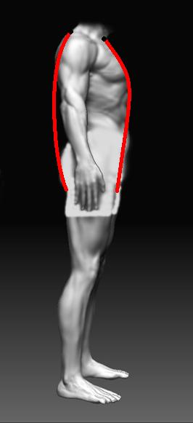

17 - Neck to Neck
Measure from the indent at the bottom
of your neck at the front, down through
your legs and up your back to the bone at
the base of your spine. Do not pull this too tight

_____

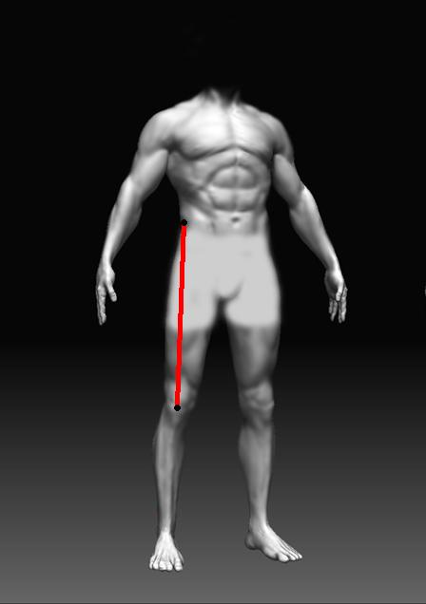
18 - Waist to Knee
Measure from the top of your hip bone
Usually the top your trousers/pants
(waist belt line) to the centre of your knee cap
Keep your knee slightly bent.
_____
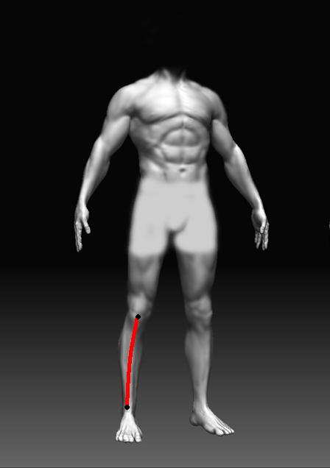

19 - Knee to Ankle
Measure from the centre of your knee cap
to your ankle (same point as outside and inside
leg)
Measurements 18 + 19 should add up to 14
outside leg figure, if they do not, please
re-measure
_____
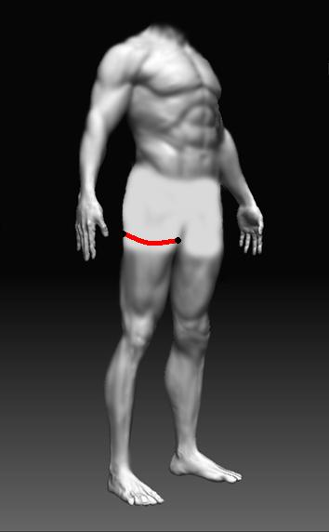

20 - Upper Thigh
Measure all the way around the top
of your thigh.

____

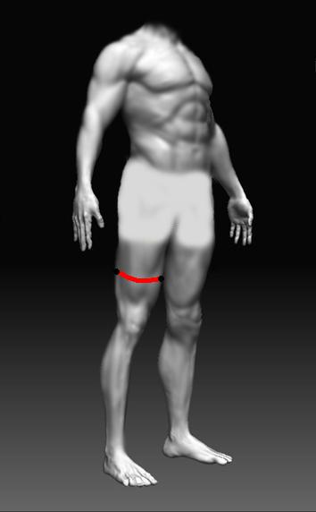
21 - Lower Thigh
Measure all the way around the lower
part of your thigh.

_____

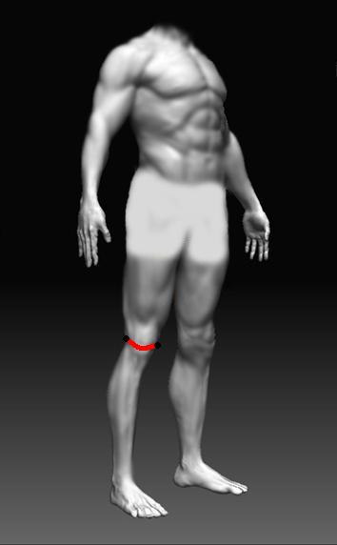

22 - Knee
Measure loosely all the way around your knee
While bent

_____

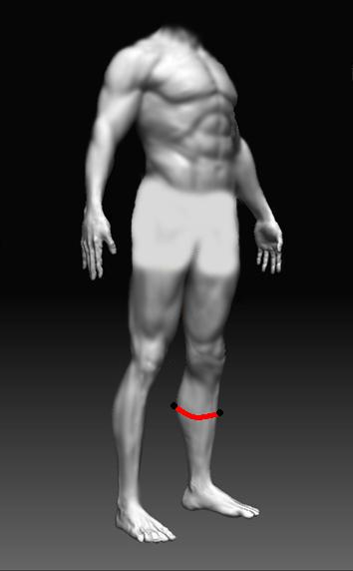
23 - Calf
Measure all the way around your
Calf at the widest point

_____

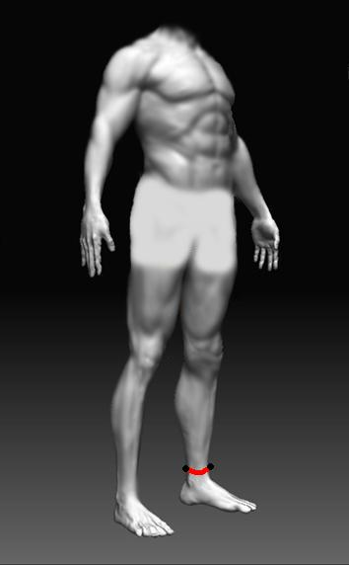
24 - Ankle
Measure all the way around your ankle

____

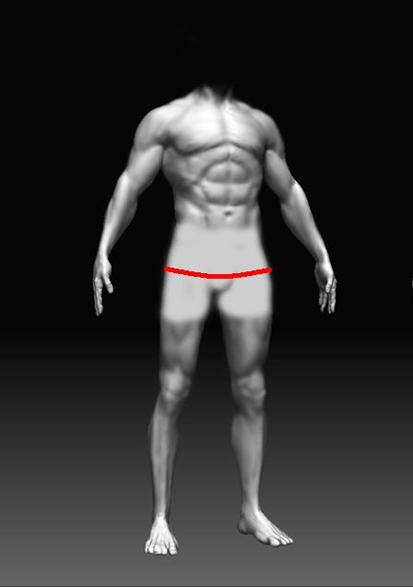
25 - Seat
Measure loosely all the way around your backside
at the widest point (around the front to back)

_____

Height :- Cms
Weight :- Kgs

Suit Order:- RaceLine Professional
Customer Name:-
Customer Email:-
Customer Phone:-

Comments:-

